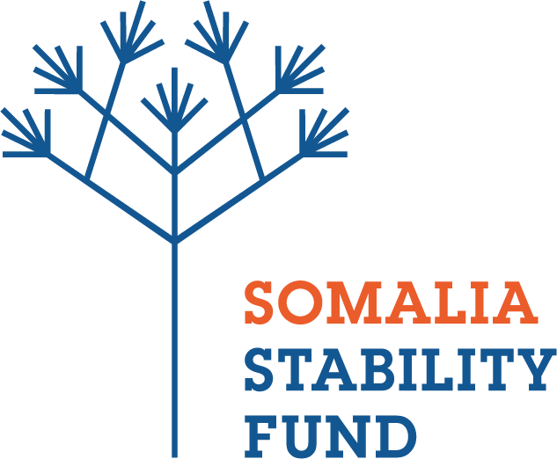
CALL FOR PROPOSAL - INVITATION TO BID (IFB)
SSFMR-005-A1
Joint Galkayo Peacebuilding Initiative

Background
The Somalia Stability Fund (SSF) is a multi-donor fund working towards a peaceful, secure, and stable Somalia. SSF is supporting government-community led conflict sensitive peace building initiative in Galkayo.
SSF is seeking organizations to implement project activities with the objective of promoting peace in Galkayo town, covering north and south Galkayo administered by Puntland and Galmudug States respectively.
To ensure conflict sensitive programming, SSF is seeking a local Somali consortium comprising of an organisation from North Galkayo (i.e. Puntland) and another organisation from South Galkayo (i.e. Galmudug) with both organisations having a proven track record in implementing peacebuilding projects, preferably in Galkayo to apply for this Call. SSF will award one (1) contract under this Call. Local organisations (both NGOs and consulting firms) from North Galkayo and South Galkayo or Puntland and Galmudug states must form a consortium/ partnership.
SSF invites proposals (“Bids”) from eligible and qualified entities or persons (“Bidders”) to undertake the works referenced above. Bidding will be competitive and is open to all qualified organizations. General details relating to the projects are highlighted below:
• Location: Galkayo
• Description of work: Implementation of Joint Galkayo Peacebuilding Initiative
• Type of Award: Accountable Grant Agreement
• Bid Closing Date: 30th November 2018
Interested Bidders are advised to click on this link https://goo.gl/kCV4uU to access the full IFB (Tender documents)
Email completed bids to procure@stabilityfund.so clearly marked: Joint Galkayo Peacebuilding Initiative SSFMR-005-A1 in the title of your email

No Clarification Questions regarding this Call for Proposals were received by the deadline of 15th November 2018.
DEADLINE FOR BID SUBMISSION: 30th November 2018 at 1400HRS East Africa Time
Email completed pbids to procure@stabilityfund.so clearly marked: Joint Galkayo Peacebuilding Initiative SSFMR-005-A1 in the title of your email
All queries must be addressed to procure@stabilityfund.so

